AUTONOMOUS BATTLE DAMAGE ASSESSMENT

MODEL DOCUMENTATION
(v1.0-Final)

DOCUMENT HISTORY

DATE | STATUS | VER | AUTHOR | NOTES
20260223 | Draft | 0.1 | Benjamin Siegel | Create model outline
20260302 | Draft | 0.2 | Benjamin Siegel | Write initial draft
20260311 | Draft | 0.3 | Benjamin Siegel | Add evaluation criteria, finalize draft
20260313 | Draft | 0.4 | Benjamin Siegel | Formatting changes
20260409 | Draft | 0.5 | Benjamin Siegel | Switch from object detector to VLM detections
20260409 | Draft | 0.6 | Benjamin Siegel | Switch from Hugging Face to Ollama
20260409 | Draft | 0.7 | Benjamin Siegel | Specific evaluation models
20260409 | Final | 1.0 | Benjamin Siegel | Final draft

Vision Language Models for Battle Damage Assessment

Model Documentation
13 April 2026

Students
- Benjamin Siegel
- Carlos Gil
- Cory Wingate
- Nicholas Lind
- William Benitez

Supervisors & Mentors
- Dr. Rajneesh Singh
- Dr. Priya Narayanan
- Derrik Asher
- Jason Pusey
- CPT Jesse Barkley

1.0 Overview
Battle Damage Assessment (BDA) estimates the effects of military action on targets. In doctrine, BDA “provides the timely and accurate estimate of damage resulting from the application of lethal and nonlethal military force [1].” This project automates key parts of that workflow using post-strike imagery. Specifically, the system identifies relevant targets within a scene and evaluates the level of damage to each object, ultimately producing a structured report so that human analysts can quickly see what was assessed, where it was located, and how damage was categorized.

The system leverages vision-language models (VLMs), which integrate computer vision and natural language processing [2]. These models are used in a zero-shot setting, meaning they are not fine-tuned on task-specific labeled military datasets. Instead, they are prompted to localize targets and assess damage directly from imagery, relying on the broad visual and semantic knowledge acquired during large-scale pretraining. This approach is particularly useful for BDA because labeled datasets of military equipment are limited, and analysts may need to detect previously unseen equipment types.

Typical applications of VLMs include scene understanding, visual question answering, and structured image description generation [2]. These capabilities align closely with the requirements of automated BDA, where a system must identify relevant targets in complex scenes and generate structured descriptions of the observed damage.

2.0 Specifications
The overall architecture of the BDA system is shown in Figure 1. Given an input image, the pipeline localizes targets by doctrinal category, generates buffered image crops for each detection, and assesses damage for each target using both the crop and full-scene context. To maintain doctrinal grounding, only doctrine relevant to the target’s category is included in the per-target prompt. The VLM outputs are consolidated into a single structured JSON report describing each target’s damage category, confidence level, supporting reasoning, and bounding box.
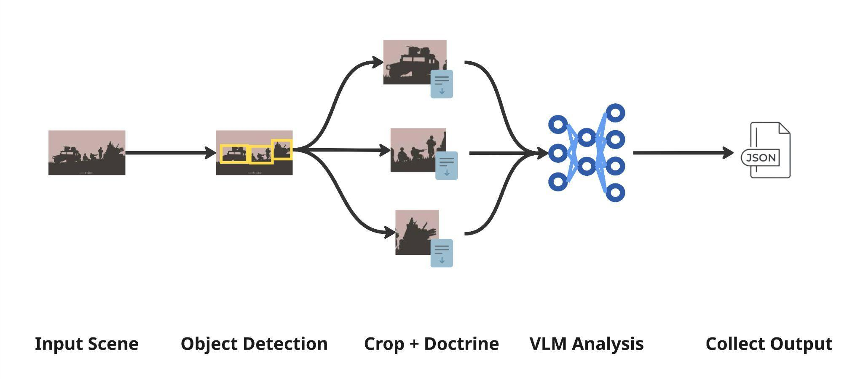
Figure 1: BDA System Architecture

The system is intentionally designed as a modular pipeline that separates localization from reasoning. In previous phases of the project, a dedicated zero-shot object detector such as Grounding DINO [3] was used for the localization phase. However, some modern VLMs are capable of producing accurate bounding boxes [4]. Experimentation suggested that the VLM-generated bounding boxes were often higher quality than those produced by standalone object detectors. This may be due to the VLM’s ability to jointly reason about scene context and task relevance when generating detections.

Model backends are served using Ollama [5], which provides local model hosting and inference capabilities. The following models are planned for evaluation due to their ability to generate high quality bounding boxes:

- Qwen family: qwen3-vl-instruct (2B, 4B, 8B, 30B-A3B, 32B, 235B)
- Google family: gemma4 (E2B, E4B, 26B, 31B), gemini-3-flash

All models will be run with 4-bit weight quantization (as default in Ollama). Both the localization VLM and assessment VLM are configurable in the system’s configuration file. This modular design is specifically chosen to enable objective comparison of alternative model configurations using both analytical performance metrics (Section 5.0) and operational metrics (inference latency), while keeping the pipeline contracts and output schema stable.

3.0 Model Run
The BDA system is designed to run locally with no external API calls at inference time, which is consistent with the operational requirements to deploy on a network-degraded edge device. The runtime stack consists of Python 3.12+ and Ollama 0.4+ with all dependencies declared in pyproject.toml [6]. All models are downloaded from Ollama and loaded locally at runtime. The current baseline uses Qwen3-VL-8B-Instruct, though final model selection will be determined during evaluation. For deployment, the system is packaged as a container image, ensuring reproducibility across environments.

The system targets deployment to an edge device running Linux with 64 GB VRAM, and evaluation is conducted on an NVIDIA H100 NVL GPU capped at 64 GB to match deployment constraints. Computational cost is dominated by VLM generation and scales primarily with image resolution and number of detections per scene. Because the evaluation phase systematically varies backend configuration, each pipeline run emits metrics containing inference time to support direct comparison across configurations. The system runs on local hardware so there are no recurring cloud inference costs. For comparison, equivalent workloads on cloud infrastructure would cost approximately $4 per GPU-hour on an A100 instance [7].

4.0 Training
No training or fine-tuning was performed. The system uses pretrained weights for all models, and adaptation is achieved entirely through prompt engineering and configuration. This zero-shot approach was chosen specifically because labeled datasets of military equipment and damaged infrastructure are scarce, and the system must generalize to previously unseen equipment types without retraining. An additional benefit is that the modular, zero-shot design allows new models to be integrated and evaluated as the field evolves without requiring a retraining pipeline.

5.0 Evaluation
A major goal of this project is to objectively evaluate automated BDA. To support this evaluation, a dataset of over two hundred human-annotated scenes with reference labels has been collected. Because the BDA system produces structured outputs describing individual targets in a scene, evaluation is performed at the target level. Each target is defined by four attributes: a doctrinal target category, a doctrinal damage category, a confidence level, and a short logic field describing supporting evidence.

Within a scene, predicted targets must be matched to reference targets. A predicted target is eligible to match a reference target only if they share the same target category. Since predictions and references include bounding boxes, spatial alignment serves as an additional matching requirement. Spatial alignment is measured using Intersection over Union (IoU) between bounding boxes. For each pair that shares the same target category and meets a minimum IoU threshold, the predicted attributes (i.e. Damage Category and Confidence) are compared against the reference attributes. Attributes are treated as ordinal values, reflecting that predictions such as “destroyed” are closer to “severe damage” than to “no damage.” Attributes with a greater disparity are penalized more heavily.

Once every reference target is compared against every predicted target, an optimal matching can be computed such that each prediction is paired with at most one reference target (subject to threshold settings). Once matching is established, detection outcomes are defined as follows:

- True Positives (TP): Predicted objects that match a reference object
- False Positives (FP): Predicted objects with no corresponding reference
- False Negatives (FN): Reference objects missed by the system

Finally, the logical quality of each target’s explanation is evaluated using an “LLM-as-a-judge” approach [8]. A separate large language model (gpt-oss-120b) reviews the predicted logic alongside the reference logic and assigns an integer score from zero to two based on whether the explanation is consistent with the reference label. This produces a target-level score combining structured accuracy components and logical consistency. Scene-level performance is computed by aggregating target scores, normalizing by the number of reference targets, and applying penalties for false positives and false negatives.

The evaluation framework is designed to capture the key capabilities required for automated BDA: accurate localization, correct damage assessment, calibrated confidence estimates, and meaningful logical explanations. By capturing key performance indicators, the system can be compared across different model variants while also tracking operational metrics such as inference time. These results will help determine which model configuration provides the best balance between analytical accuracy and computational efficiency for deployment on edge hardware.

In addition to evaluating locally deployable models, two cloud-hosted models are included as reference baselines: the qwen3-vl-235b model and the gemini-flash model. These models are not intended for deployment due to operational constraints, but instead serve as proxies for state-of-the-art performance.

The current phase of the project has focused on validating the end-to-end pipeline, containerized deployment, and evaluation framework. Initial evaluation has been conducted on a subset of twenty images using a single model configuration. While these results are preliminary, they demonstrate that the system can successfully execute the full assessment pipeline and produce structured outputs suitable for scoring. The next phase will expand evaluation across the full dataset and model configurations, enabling a final comparison of performance and operational efficiency.

6.0 Reflection
Working on this document helped us formalize the evaluation procedure and clarify the reference data format, particularly the need for bounding boxes to enable precise target matching and scoring. It also reinforced the value of separating detection from reasoning, as we have seen better results by breaking the overall task into smaller, well-defined steps. Overall, documenting these decisions made our design choices more deliberate and clarified how each component contributes to the overall system.

7.0 Changes To Previous Deliverables
Several changes have been made since the previous deliverable. First, the pipeline no longer relies on a dedicated object detection model for localization but rather uses a VLM for more context-aware identification of targets. Second, the system has transitioned to using Ollama as the model serving framework, which better aligns with the project sponsor requirements. Third, a defined set of VLMs has been identified for systematic evaluation, enabling objective comparison across model sizes and variants. Finally, the evaluation dataset has been expanded significantly, increasing the number of annotated scenes and improving the reliability of future assessments.

References

[1] Joint Chiefs of Staff, CJCSI 3162.02A: Methodology for Combat Assessment. Washington, DC, USA: Joint Staff, Jul. 16, 2021.

[2] Hugging Face, “Vision-language models (VLMs),” Hugging Face Blog. [Online]. Available: https://huggingface.co/blog/vlms. [Accessed: Mar. 14, 2026].

[3] Hugging Face, “Grounding DINO,” Hugging Face Documentation. [Online]. Available: https://huggingface.co/docs/transformers/en/model_doc/grounding-dino. [Accessed: Mar. 14, 2026].

[4] Qwen Team, “Qwen3-VL Technical Report,” arXiv:2511.21631, 2025. [Online]. Available: https://arxiv.org/abs/2511.21631. [Accessed: Mar. 14, 2026].

[5] Ollama, “Ollama,” Ollama. [Online]. Available: https://ollama.com/. [Accessed: Apr. 9, 2026].

[6] cmu-bda, “bda-svc,” GitHub repository. [Online]. Available: https://github.com/cmu-bda/bda-svc. [Accessed: Mar. 14, 2026].

[7] Microsoft, “Azure pricing calculator,” Microsoft Azure. [Online]. Available: https://azure.microsoft.com/en-us/pricing/calculator/. [Accessed: Mar. 14, 2026].

[8] Z. Li et al., “A Survey on LLM as a Judge,” arXiv:2411.15594, 2024. [Online]. Available: https://arxiv.org/abs/2411.15594. [Accessed: Mar. 14, 2026].

